HANU Training Management System

Use-Case-Realization Specification: Dormitory Payment

Version <1.0>

*[Note: The following template is provided for use with the Rational Unified Process. Text enclosed in square brackets and displayed in blue italics (style=InfoBlue) is included to provide guidance to the author and should be deleted before publishing the document. A paragraph entered following this style will automatically be set to normal (style=Body Text).]*

*[To customize automatic fields in Microsoft Word (which display a gray background when selected), select File>Properties and replace the Title, Subject and Company fields with the appropriate information for this document. After closing the dialog, automatic fields may be updated throughout the document by selecting Edit>Select All (or Ctrl-A) and pressing F9, or simply click on the field and press F9. This must be done separately for Headers and Footers. Alt-F9 will toggle between displaying the field names and the field contents. See Word help for more information on working with fields.]*

Revision History

| **Date** | **Version** | **Description** | **Author** |
| --- | --- | --- | --- |
| December 05, 2021 | 1.0 | Draft | Lai Hanh Van |
| December 08, 2021 | 1.0 | Final | Lai Hanh Van |
|  |  |  |  |
|  |  |  |  |

Table of Contents

1. Introduction 2

1.1 Purpose 2

1.2 Scope 2

1.3 Definitions, Acronyms, and Abbreviations 2

1.4 References 2

1.5 Overview 2

2. Flow of Events—Design 2

3. Derived Requirements 2

Use-Case-Realization Specification: Dormitory Payment (Student)

# Introduction

## Purpose

This document describes how the Dormitory Payment Use-Case is realized within the design model, in terms of collaborating objects.

## Scope

This document only applies to the Dormitory Payment use-case, within the EDMS of HANU.

## Definitions, Acronyms, and Abbreviations

User – a person who uses the system, can be a student or teacher.

Administrator - a person who is responsible for the activities in the system.

EDMS - Educational Management System

HANU – Hanoi University

## References

[1] ***Use-case Specification: Dormitory Payment***, Lai Hanh Van, December 06, 2021, HANU Training Management System.

## Overview

In the following section, Use-Case Realization Specification of the Dormitory Payment Use-Case of the HANU's Training Management System is provided in detail. The first section contains sequence diagrams describing how the use case is realized in terms of collaborating objects. The second section includes class diagrams with relationships that participate in the realization of the use case. The last section is an analysis of all requirements, such as non-functional requirements, on the use-case realization that are not considered in the design model, but that need to be taken care of during implementation.

# Flow of Events—Design

* There are four types of objects in this use-case realization: PaymentView, PaymentController, Payment, and PaymentData, which is a data access class.
* The sequence diagram shows the order in which class operations are called.
* There is a class diagram that shows the structure of each of the above-mentioned classes, their relationships, and the type hierarchies in which they participate.

## Sequence diagram

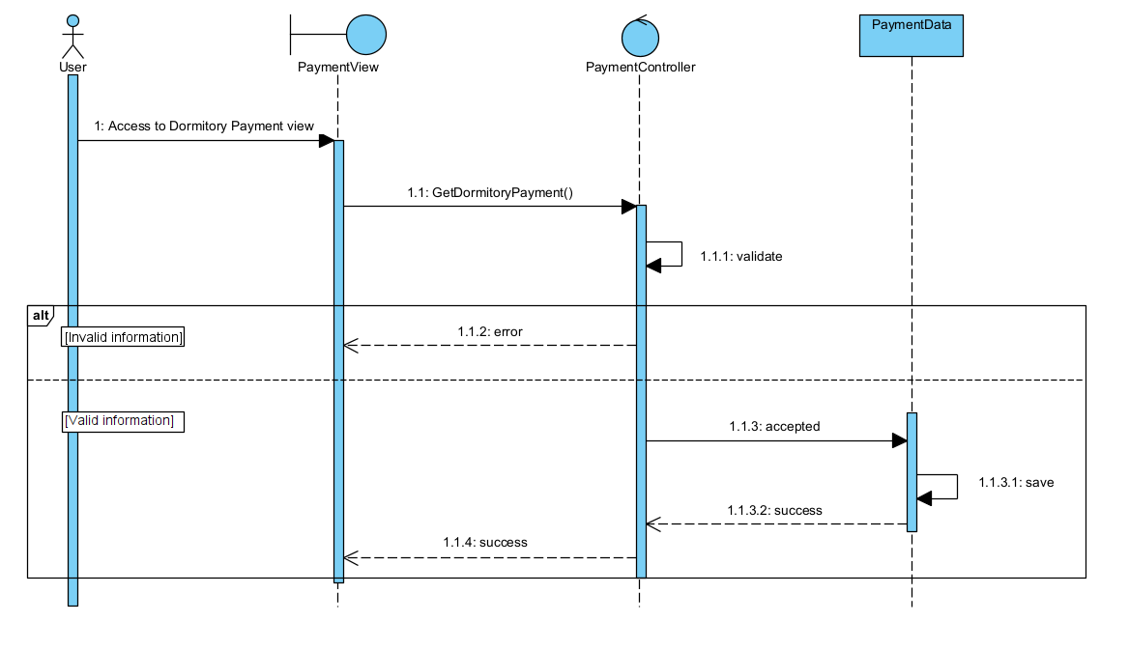

## Class diagram

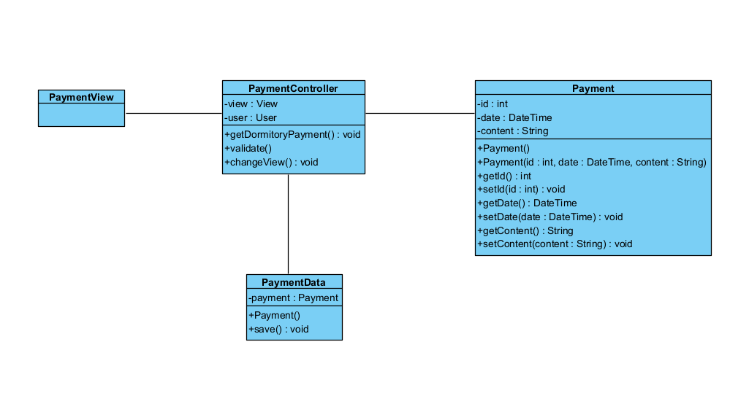

# Derived Requirements

There are no derived requirements in this use case.